H.T No
Regulations:
A18

Sreenidhi Institute of Science and Technology
(An Autonomous Institution)
Code No: 7HC07 Date: 18-Mar-2023 (AN)

B.Tech I-Year I- Semester External Examination, March/April-2023 (Supplementary)
MATHEMATICS - I (CSE, IT and ECM)

Time: 3 Hours Max.Marks:70

Note: a) No additional answer sheets will be provided.
b) All sub-parts of a question must be answered at one place only, otherwise it will not be valued.
c) Missing data can be assumed suitably.
Bloom's Cognitive Levels of Learning (BCLL)

Remember | L1 | Apply | L3 | Evaluate | L5
Understand | L2 | Analyze | L4 | Create | L6

Part - A Max.Marks:20

Answer all QUESTIONS.

 |  | BCLL | CO(s) | Marks
1 | Apply Maclaurian’s series expansion of 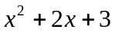 | L3 | CO1 | [2M]
2 | Evaluate 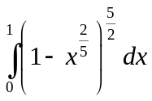 | L5 | CO2 | [2M]
3 | Find the rank of the matrix 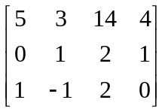 | L5 | CO3 | [2M]
4 | Define Hermitian matrix | L5 | CO4 | [2M]
5 | Write the rank and nullity theorem. | L6 | CO5 | [2M]
6 | Define inner product space and give an example. | L6 | CO6 | [2M]
7 | Find the Taylors series expansion of 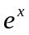 in the powers of 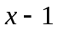 | L3 | CO1 | [2M]
8 | Define rank of the matrix. | L6 | CO3 | [2M]
9 | Define vector space. | L6 | CO4 | [2M]
10 | Evaluate 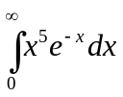using Beta functions. | L5 | CO2 | [2M]
6
Part – B Max.Marks:50
ANSWER ANY FIVE QUESTIONS. EACH QUESTION CARRIES 10 MARKS.

 |  |  | BCLL | CO(s) | Marks
11. | a) | Verify Rolle’s theorem for 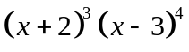in 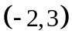 | L2 | CO1 | [5M]
 | b) | Using Taylors theorem , prove that  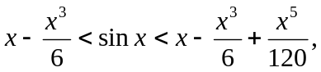 for  | L3 | CO1 | [5M]
12. | a) | Express in terms of beta and gamma functions 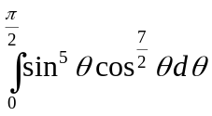 | L3 | CO2 | [5M]
 | b) | Find the evaluate of the curve 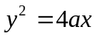 | L5 | CO2 | [5M]
13. | a) | Solve the system of equations 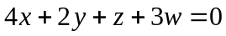,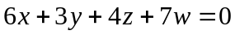,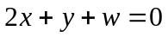 | L5 | CO3 | [5M]
 | b) | Find the inverse of the matrix 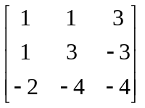using Gauss-Jordan method. | L5 | CO3 | [5M]
14. | a) | Find the Eigen values and Eigen vectors of the matrix 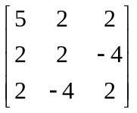 | L5 | CO4 | [5M]
 | b) | Diagonalize the matrix 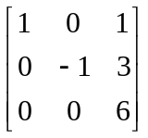 | L1 | CO4 | [5M]
15. | a) | If 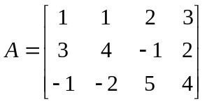find a basis, Null space(A) and verify rank-nullity theorem. | L3 | CO5 | [5M]
 | b) | Verify the following vectors for dependence 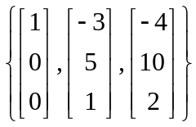 | L4 | CO5 | [5M]
16. | a) | Find the orthonormal basis for the vectors  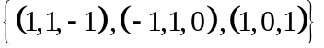 | L5 | CO6 | [5M]
 | b) | Show that the function that take 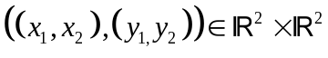  to 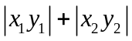 is not an inner product on 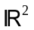 | L2 | CO6 | [5M]
17. | a) | Verify Cauchy’s mean value theorem for the functions  and in the interval  | L3 | CO1 | [4M]
 | b) | State and prove the relation between beta and gamma functions. |  | CO2 | [3M]
 | c) | Solving the system of equations | L5 | CO3 | [3M]
18. | a) | Verify Cayley-Hamilton theorem for the matrix 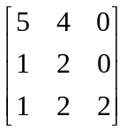 | L3 | CO4 | [4M]
 | b) | Find the basis of 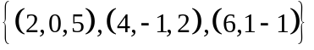 | L3 | CO5 | [3M]
 | c) | Show that the function that take 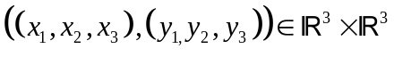  to 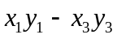 is not an inner product on 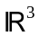 | L2 | CO6 | [3M]

-- 00 -- 00 –

